

**Hallo - 015 Challenge**

Greetings challenger, and welcome to the following challenge.

**Tip:** read the entire assignment before you start (2 parts).

**Part 1 - server node js + mysql:**

You have a file named data.json This file contains information about people's names, jobs and salaries.

**Your Challenge:**

Use this file to as mock data in your sql table

And create rest api with 4 end points -

1. Get the person with the highest salary by job (transfer the job value as query param)
2. Get the Object or array of objects that give information about all the jobs and calculate average salary of the different jobs

The object should look something like this (**this is just a recommendation**) :

{

Psychologist:13500,

Web Developer:12300

}

1. Get all jobs names and they popularity, for popularity you need to count the amount of people who work in the same job
2. Post a new row to the database if the name of people already exists, update its work and salary.

Requirements-

* Please use node js
* You can chose you own implementation for the api using express or other packages like nest
* For mysql you can choose any package that you want mysql2/promise ,sequelize

**Part 2 - client vue:**

In this task we want you to use your api in the client.

Create one page - with table like this

| Job | Avg salary | Person name with the highest salary in this job |
| --- | --- | --- |
| Web developer | 23412 | Ploni Almoni |



And a chart that compares jobs popularity look something like this.

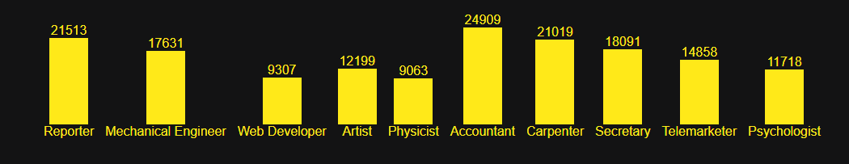

Requirements:

* Please use vue.js and use any version that you want.
* Do not use any packages for api request use only fetch
* Do not use any chart or table libraries

Notes:

* Code readability is super important!
* Thinking about performance is a advantage
* Tests too (if u have the time) are more than welcome

For any questions please feel free to contact us.

Submit your solution to any source code management like Gitlab/Github/BitBucket etc..